Illinois Medicaid messaging toolkit for the end of continuous coverage
Key messages and template communications.
Questions or requests? Email hfs.communications@illinois.gov.

What is Medicaid continuous coverage, when will it end, and what will happen when it ends?
For answers to these questions and more, visit our FAQ page: Illinois Medicaid and the end of continuous coverage

How You Can Help
Use this toolkit to help Medicaid Customers get ready to renew.

Healthcare Providers:
Please put a system in place to get Medicaid customers ready to renew and connected to coverage using the main messages and templates below to describe the steps they need to take.

You can work with them during check-in, in appointment reminders, during appointment reminders, and during checkout. Use your MyChart or your patient portal to send reminders throughout the year. If you have an email or text list, use that repeatedly. If your check-in staff can see renewal due dates, train them to tell customers when they are due to renew and what they need to do to get ready. Hand out and post written material. Put a computer in your waiting room and set the homepage to abe.illinois.gov so people can click on “Manage My Case” to update their address or check their due date (also called redetermination date) and manage their case.

Everybody’s due date is different, and repetition is key to adoption, so please set up systems to consistently deliver this messaging throughout the year.

Nonprofits, Advocates, and Other Non-Providers Working with Medicaid Customers:
We need your help to reach people who have Medicaid! Please spread these key messages and use the templates below to help people get ready to renew and connect to coverage. Repetition is key to adoption, so please use these messages in multiple places, multiple times.

Make a list of the ways you interact with Medicaid customers and plan how you can incorporate these into your standard operating procedures. If you have an email list, send multiple emails throughout the year. If you have a check-in counter, post our flyer and keep a stack of palm card printouts. If your staff has 1:1 contact with people who use Medicaid, train them to use these messages. If you are a food bank, slip flyers into each grocery bag.

Main Messages

Got Medicaid? Get ready to renew! Click Manage My Case at abe.illinois.gov.

Illinois is checking to see if you are still eligible for Medicaid. Here’s what you need to do now:

Click Manage My Case at abe.illinois.gov to:
- Verify your mailing address under “Contact Us.”
- Find your due date (the “redetermination” date) in your "Benefit Details."

Watch your mail and complete your renewal right away.

If you are no longer eligible for Medicaid, connect to coverage at work or through the official Affordable Care Act (ACA) Marketplace for Illinois, GetCoveredIllinois.gov.

Call 1-800-843-6154 for help with your renewal.

Templates
You can edit these templates to meet your needs and specific audience, but please try to adhere close to the original messaging.

Text
SMS:
Get ready to renew your Medicaid! Find your due date & verify your mailing address at abe.illinois.gov (click Manage My Case) or 1-800-843-6154. Txt STOP=stop

MMS:
Get ready to renew your Medicaid! Illinois is checking to see if you are still eligible for Medicaid. You need to verify your mailing address and know your due date to make sure you get your renewal letter. Click Manage My Case today at abe.illinois.gov or call 1-800-843-6154. STOP = unsubscribe.

Flyer
[Print the flyer file in the toolkit and post in highly visible areas. Print flyers and hand them to customers at check in or check out].

Got Medicaid? Get ready to renew! Manage your case at abe.illinois.gov.

Illinois is checking to see if you are still eligible for Medicaid. Here’s what you need to do now:

Click Manage My Case at abe.illinois.gov to:
- Verify your mailing address under “contact us.”
- Find your due date (also called redetermination date) in your “benefit details”.

Watch your mail and complete your renewal right away.

If you are no longer eligible for Medicaid, connect to coverage at work or through the official Affordable Care Act (ACA) Marketplace for Illinois, GetCoveredIllinois.gov.

Get ready to renew your Medicaid!
[QR code to abe.illinois.gov] Scan here and click Manage My Case now.
1-800-843-6154

Palm Card
Got Medicaid? Get Ready to Renew!

- Click Manage My Case at
abe.illinois.gov.
- Verify your address.
- Get your due date
(redetermination date).
- Watch your mail.
- Complete your renewal.

Scan here and click Manage My Case.
[QR code to abe.illinois.gov]
1-800-843-6154

Social Media Posts
🚨 Medicaid renewal alert 🚨
Illinois is checking to see if you are still eligible for Medicaid 🚑❤️💊. Get your due date (redetermination date) and verify your mailing address so you get your renewal letter 📧. Click Manage My Case at abe.illinois.gov or call 1-800-843-6154.
[attach social media graphic]

📣 Got Medicaid? Don’t risk losing your health insurance 🚑❤️💊! Verify your mailing address with Illinois Medicaid 💌. Click Manage My Case at abe.illinois.gov or call 1-800-843-6154. [attach social media graphic]

#GotMedicaid? Illinois is checking if are still eligible for Medicaid. Click Manage My Case at abe.illinois.gov or call 1-800-843-6154 to verify your address and find your due date (redetermination date). [attach social media graphic]

Email / Letter
If email, use subject: Re: Got Medicaid? Get ready to renew!
If possible, use preheader: Here’s what you need to do now

Dear NAME/MEDICAID MEMBER,

Get ready to renew your Medicaid!

You have not had to renew your Medicaid since the Covid-19 pandemic began. Medicaid pays for your healthcare, like doctor visits, prescription medicine, and urgent emergency services.

Now Illinois is starting renewals again to see if you are still eligible. Everybody’s renewal date is different, so it is critical that you get ready to renew.

Don't risk losing your Medicaid! Here is what you need to do:

1. Click Manage My Case at abe.illinois.gov
Create or login to your account at abe.illinois.gov to manage your benefits. Online is the best way to connect.

2. Verify your address
If you use Medicaid, you need to keep your address current. Click Manage My Case and verify your household information under ‘Contact Us,' or call 1-800-843-6154.

3. Find your due date (also called a redetermination date).
Your renewal is due once per year. To find your due date (redetermination date), check your ‘Benefit Details’ tab at abe.illinois.gov. Do you want reminders when it’s time to renew? Opt-in for text and email alerts in the ‘Account Management’ tab under ‘Manage your communications preferences.’

4. Watch your mail
We will mail your renewal a month before it is due. You will get an official letter about your Medicaid status. It will tell you if you need to complete a renewal form to renew your benefits. The envelope will look like this:
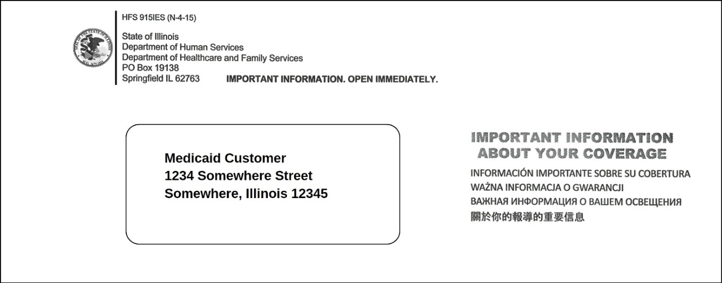

5. Complete your renewal
If your letter says you need to, complete and submit your renewal before the due date (also called redetermination date) to avoid losing your Medicaid. To renew, click Manage My Case at abe.illinois.gov, mail your form according to the letter, or call 1-800-843-6154.

Connect to coverage
If you are no longer eligible for Medicaid, it is important to quickly get other health insurance to avoid a lapse in coverage.

You can ask your employer if health insurance is offered or you can visit Getcovered.illinois.gov to shop for quality, affordable coverage provided under the Affordable Care Act (ACA). You usually have 30-60 days to enroll in a new plan. This is called a "Special Enrollment Period.”

Get Covered Illinois is the official ACA Health Insurance Marketplace for the state of Illinois, helping you shop for health insurance to fit your needs and budget. Health plans offered on the ACA Health Insurance Marketplace cover pre-existing conditions and essential health benefits, including preventive care and mental health services.

Visit getcoveredillinois.gov for more information, free enrollment assistance, and to find out if you may qualify for financial help. Many people find plans for $10 or less per month after tax credits.

Get ready to renew! Verify your address and find your renewal date now at abe.illinois.gov.

Newsletter / Drop-in Article
Get ready to renew your Medicaid! Medicaid customers have not had to renew their Medicaid coverage since the Covid-19 pandemic began. Medicaid pays for healthcare, like doctor visits, prescription medicine, and urgent emergency services.

Now Illinois is starting renewals again to see if people are still eligible. Everybody’s renewal date is different, so it is critical that you get ready to renew.

Don't risk losing your Medicaid! Here is what you need to do:

Click Manage My Case at abe.illinois.gov to:
- Verify your mailing address under “contact us.”
- Find your due date (also called redetermination date) in your “benefit details”.

Watch your mail and complete your renewal right away.

If you are no longer eligible for Medicaid, connect to coverage at work or through the official Affordable Care Act marketplace for Illinois, GetCoveredIllinois.gov.

Get ready to renew your Medicaid! Click Manage My Case at abe.illinois.gov or call 1-800-843-6154.

Phone Script
Hi, this is YOUR NAME from YOUR ORGANIZATION. Is NAME OF HEAD OF HOUSEHOLD there? [Wait for response.]

Hi NAME OF HEAD OF HOUSEHOLD, how are you doing today? [Wait for response]

I'm calling because Illinois is starting to review everybody’s Medicaid to see if they still qualify, and I want to make sure you are ready to renew your benefits. Do you have a minute to hear the three steps you need to take to be ready to renew? [Wait for response].

I suggest you write this down if you can. Do you want a second to get something to write with? [Wait for response.]

OK, Number 1: Create or login to your account at abe.illinois.gov. If you haven’t already, set up your account by clicking “Manage My Case.” This is important so that you can update your household information and get your due date, which is also called redetermination date. That’s Abe—a, b, e—dot, Illinois, dot, g, o, v, “Manage My Case.”

Number 2: Verify your address and get your renewal date. Make sure Illinois Medicaid has your correct mailing address, so they send your paperwork to the right place. Click “Manage My Case” and go to the ‘Contact Us’ page to see the address they have for you. Click the link if you need to update it. Your renewal due date is on the ‘benefit details’ page. They call it a “redetermination” date.

Number 3. Watch your mail. You will get a letter about your coverage a month before your renewal date. It will be a plain black and white envelope with the official State of Illinois seal on it, along with the phrase “Important Information About Your Coverage” on the front in a few different languages. It will tell you if you need to complete a form to renew your benefits. If your letter says you need to, complete and submit the paperwork according to the instructions in the letter.

OK, that’s it. Do you have any questions? [Wait for response].

Now, the hardest part about this whole process is going to be signing into that website. If you want, I can help you with that right now just to make sure you get in. Do you have a second to do it now? [Wait for response]. OK, let’s get started!

[Open the Manage My Case instructions and the ABE Guidance for Customers as a reference while you walk them through the steps.]

Step 1: Go to abe.illinois.gov. Let me know when it loads.
Step 2: Click on the green “Manage My Case” button
- Do you have an ABE Account? If so, enter your user ID and password now. Otherwise, click ‘Create an ABE account’ to get a new login. [wait for them to create a new ABE account]
- I suggest you write down your login and keep it somewhere safe.
Step 3: After logging in, you should be in the ‘Case Summary’ page. Click ‘Link your account.’
- You will be asked to answer a few questions to confirm your identity. For your own protection, please do not tell me any of this information as you enter it. Let me know when you finish.
Step 4: Let’s confirm your address. Go to the ‘Contact Us' page. Do you see the address they have for you? If that isn’t right, click the link to submit an address change.
Step 5: Go to your ‘benefit details' page. Do you see your redetermination date? Write that down. They will send your letter a month before that date.

OK, congratulations NAME OF HEAD OF HOUSEHOLD, you are officially ready to renew! You’ve taken an important step to make sure you stay connected to coverage. Do you have any more questions for me before we go? [Wait for response]

Thank you for taking my call today, and thank you for taking care of your healthcare. [Wait for response, end call.]

